## Bootstrapping:

1. After completing the walk through I have the following errors:

**For running Android --**

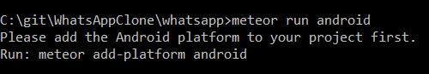

**For npm start --**

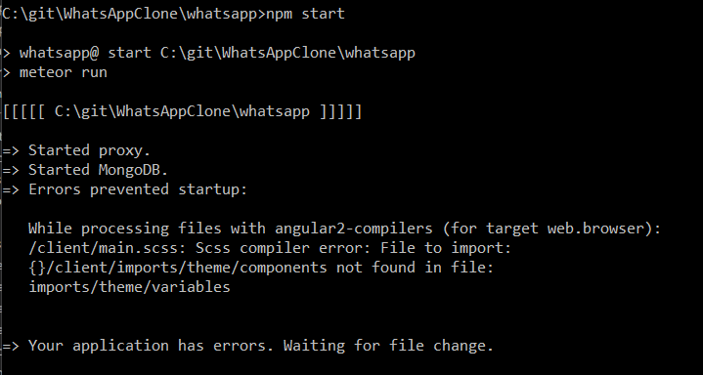

## Chats Page

No change to error messages